http://www.ruanyifeng.com/blog/2019/08/web_components.html
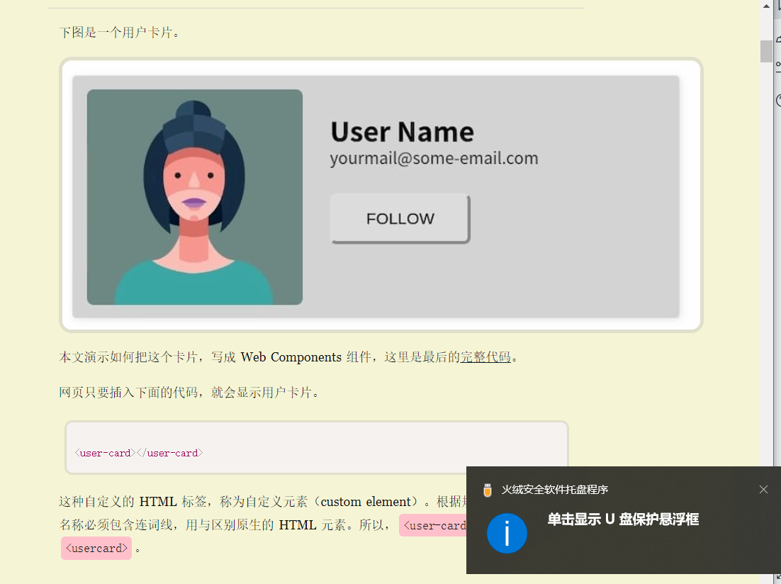

https://blog.csdn.net/HaoDaWang/article/details/76649126
